**Machine Learning Basics**

**12/1/2022**

1. Concepts of Supervised Learning (e.g., image classification), Unsupervised Learning (e.g., clustering)

2. Supervised Learning example: Learn the parameter K for the K-Nearest Neighbor based voting

3. Difference of classification and regression

4. Linear regression: y = h*x + h0, where x could be single or multi-dimensional features. For example, housing price prediction.

5. Logistic Sigmoid Function:

6. Logistic Regression:

β1: coefficient; β0: intercept

For example:

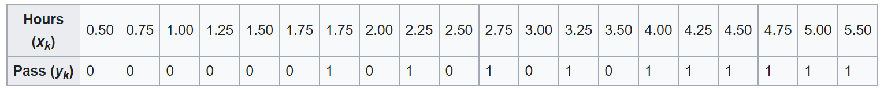

Images from: <https://en.wikipedia.org/wiki/Logistic_regression>

**See the demo Python code for Linear Regression and Logistic Regression on Blackboard.**